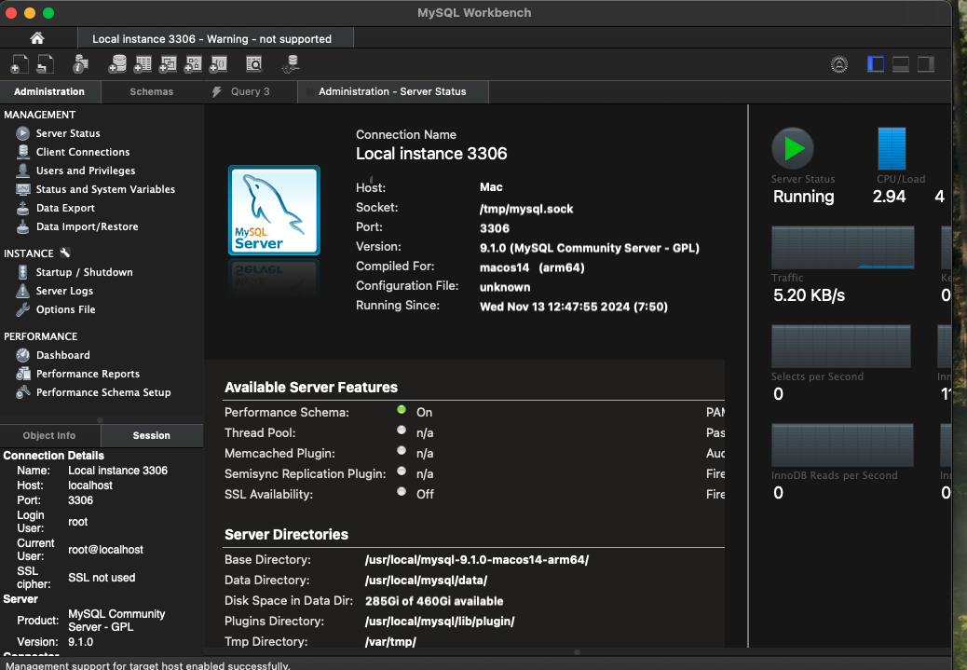Fig 1.0 Connection through **MySQL Workbench 8.0.40**

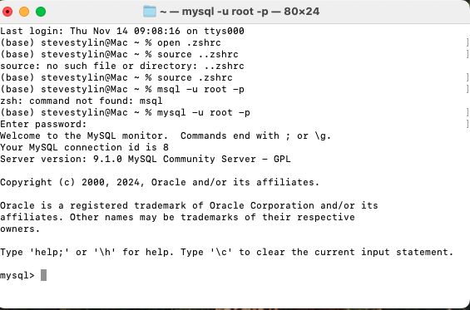  
Fig 1.1: Connection with terminal

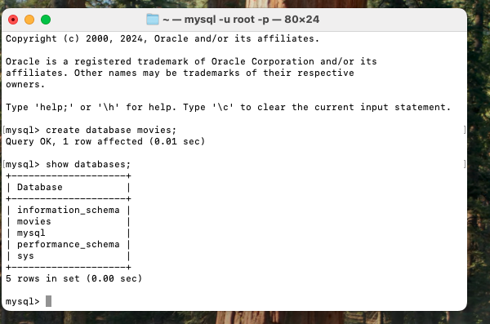

Fig 1.2 Create database movies in MySQL prompt terminal.

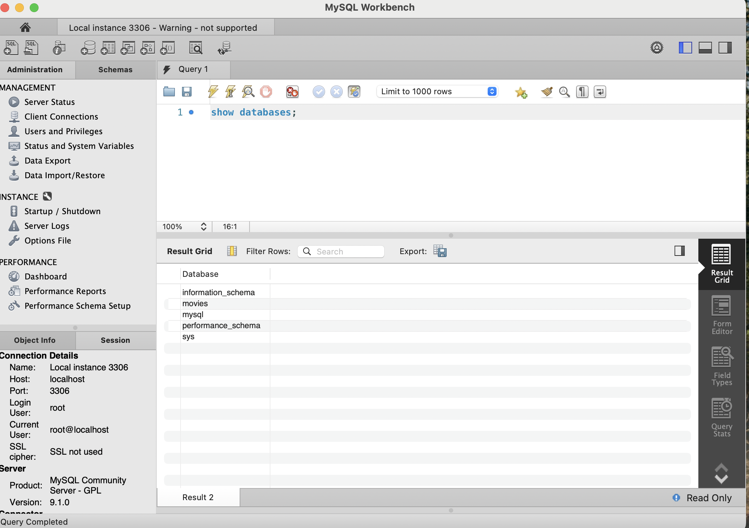

Fig 1.3 Viewing all databases